**PROCESS:-**

A process can be thought of as a program in execution. A process needs certain resources – such as CPU time, memory, files, I/O devices to accomplish its task. These resources are allocated to the process either when it is created or while it is executing.

**Process State:-**

As a process executes, it changes State. The state of a process is defined in part by the current activity of that process. A process may be in one of the following states:-

* New – The process is being created.
* Running – Instructions are being executed.
* Waiting – The process is waiting for some event to occur.
* Ready – The process is waiting to be assigned to a processor.
* Terminated – The process has finished execution.
* 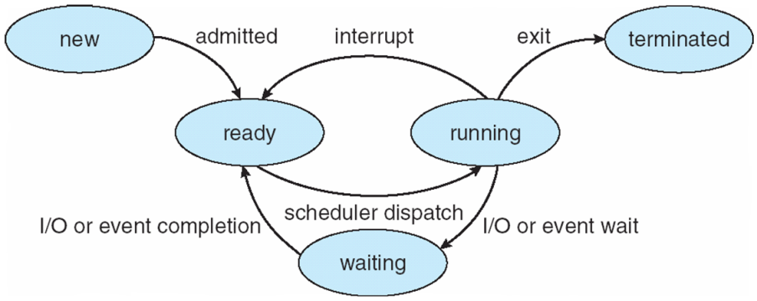

**CPU** **SCHEDULING**

It is a process which allows one process to use the CPU while the execution of another process is on hold due to unavailability of any resources like I/O etc , thereby making full use of CPU.

**CPU SCHEDULING CRITERIA**

There are several criteria to consider when try to select the “best” scheduling algorithm for a particular situation and environment, including:

* CPU utilization – Keep the CPU as busy as possible.
* Throughput – if the CPU is busy executing processes, then work is being done. One measure of work is the number of processes that are being completed per unit of time, called throughput.
* Turnaround time – it is the sum of the periods spent waiting, executing on the CPU and doing I/O.
* Waiting time – it is the sum of the periods spent waiting in the ready queue.
* Response time – it is the time from submission of request until the first response to be produced.

**SCHEDULING ALGORITHM**

FCFS: It is the simplest scheduling algorithm. It simply queues processes in the order that they arrive in the ready queue. In this, the process that comes first will be executed first and next process starts only after the previous gets fully executed.

SJF: It is the best approach to minimize waiting time. In this, the process that has shortest job will be executed first and next process starts only after the previous gets fully executed.

ROUND ROBIN: It is an arrangement of choosing all elements in a group equally in some rational order, usually from the top to the bottom of a list and then starting again at the top of the list and so on.

PRIORITY: In this each process is assigned a priority. Process with the highest priority is to be executed first and so on. Processes with the same priority are executed on first come first serve basis. Priority can be decided based on memory requirements, time requirements or any other resource requirement.